SAMPLE SPONSORSHIP LETTER AND PACKAGE
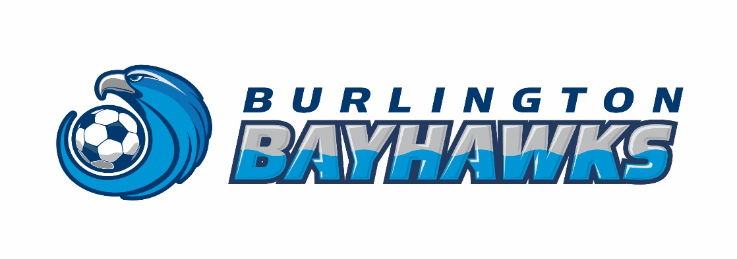
Thank you for considering supporting the Burlington Bayhawks B/GXXA/B/C rep soccer team. We are part of the Burlington Youth Soccer Club (BYSC), a not-for-profit organization. The league we play in (state league name here) is affiliated with Ontario Soccer. The Burlington Bayhawks B/GXXA/B/C is a team that has received much media attention. For instance, due to significant achievements and numerous championships, our team was previously selected for filming on Cogeco TV, was written-up in SportsXpress magazine, and has appeared several times in the Burlington Post.

This season we will be travelling from (list geographic region here) to compete in league games. During the indoor season, we will be competing in (list indoor tournaments / leagues here). We are also preparing to play in (list outdoor tournaments here) during the outdoor season.

The large geographic area within which we play will help to give your company increased exposure in these respective communities and will show your community involvement. In addition, all of the Burlington Bayhawks sponsors are recognized in a Sponsor List in the Burlington Post each year (September) as well as on the BYSC website.

All funds generously donated by our sponsors will be used to purchase team equipment, pay tournament entry fees, field permits, referee fees, indoor facility rentals, team academy fees, and will provide additional training opportunities for the players.

Our sponsor commitments range from $1,500+ to $250. We have enclosed our Sponsorship Package for your review.

We would be proud to add your company’s name to our list of sponsors.

Thank you for your support!

Sincerely,

_____________________ _____________________
XXX XXX
Head Coach Sponsorship Coordinator
Burlington Bayhawks Burlington Bayhawks

SAMPLE RECEIPT - SPONSOR

3370 South Service Rd., Suite 200, Burlington, Ontario L7N 3M6 (T) 905-333-0777 (F) 905-333-9127

Receipt

To: XXXX
Burlington, Ontario

Date Item Paid
February, 2018 Sponsorship UXXA/B/C-G/BXXA/B/C $250.00 for the 2018 Outdoor Season

The Burlington Youth Soccer Club is a not-for-profit organization.

NFP #000418243

SAMPLE THANK YOU LETTER - SPONSOR
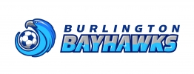

Burlington Bayhawks B/GXXA/B/C Rep Soccer Team
(Burlington Youth Soccer Club)

MONTH DATE, 2018

XXX
Burlington, ON

Dear XXX:

On behalf of the Burlington Bayhawks B/GXXA/B/C team, we would like to express our sincere appreciation for your ongoing sponsorship during the 2012 outdoor soccer season! The Bayhawks are having a great season, having done very well in (xxx…list accomplishments here).

As always, the money generously donated by your company goes directly towards offsetting the cost of our team expenses such as tournaments, exhibition games, equipment and training programs, etc…

Thank you once again for your support! We appreciate and value your sponsorship.

Sincerely,

XXXX XXXX
Head Coach Sponsorship Coordinator
Burlington Bayhawks Burlington Bayhawks

PLATINUM - Sponsorship level $1500 +

Sponsors Corporate Name alone on back of Home Team Jersey
Sponsor’s Corporate Logo and Link on our TeamSnap website: www.xxxx.com
Sponsor’s Name in Burlington Post and on Burlington Youth Soccer Club sponsors page
Sponsor’s Corporate Logo on back of team practice jerseys
Team photo to link to Sponsor’s own website
Team Plaque

GOLD - Sponsorship level $ 1000 +

Sponsor’s Corporate Name alone on back of Away Team Jersey
Sponsor’s Corporate Logo and Link on our TeamSnap website: www.xxxx.com
Sponsor’s Name in Burlington Post and on Burlington Youth Soccer Club sponsors page
Sponsor’s Corporate Logo on back of team practice jerseys
Team photo to link to Sponsor’s own website
Team Plaque

SILVER - Sponsorship level $ 750 +

Sponsor’s Corporate Logo on Team Banner (Displayed at all games and tournaments)
Sponsor’s Corporate Logo and Link on our Website www.xxxx.com
Sponsor’s Name in Burlington Post on Burlington Youth Soccer Club sponsors page
Sponsor’s Corporate Logo on back of team practice jerseys (4” x 4”)
Team photo to link to Sponsor’s own website
Team Plaque

BRONZE - Sponsorship level $ 500 +

Sponsor’s Corporate Logo on Team Banner (Displayed at all games and tournaments)
Sponsor’s Corporate Logo and Link on our Website www.xxxx.com
Sponsor’s Name in Burlington Post on Burlington Youth Soccer Club sponsors page
Sponsor’s Corporate Logo on back of team practice jerseys
Team Plaque

FRIENDSHIP - Sponsorship level $250+

Sponsor’s Corporate Logo on our Website www.xxxx.com
Sponsor’s Name in Burlington Post on Burlington Youth Soccer Club sponsors page
Sponsor’s Corporate Logo on back of team practice jerseys

*All sponsors will be mentioned in any promotional material (ie. local newspaper, magazine articles, etc.) throughout the season, when possible.
**Our Team Website is www.xxxx.com. The site is used daily for broadcasting our schedules, calendar of events, latest news, team and tournament updates, game photos and game results.
Please make cheques payable to “(bank account name here)”.

